You are invited to take part in a Children’s event!

On Wednesday, October 28, we would like to have as many people/groups of PBC to join us in decorating the trunks of cars/beds of trucks for a “Trunk or Treat” event for children & their families within our children’s ministries. They will be invited to “trick or treat” at each vehicle as they circle the parking lot. It is a great time for the children to enjoy the evening and not feel scared about trick-or-treating. We will also have prizes for the Top 3 most creative vehicles.

PBC TRUNK OR TREAT PARTICIPANT GUIDELINES 2020

Wednesday, Oct 28, 2020
7:00-8:30 pm
Participating Car Arrival Time: before 6:15 pm

Car/Truck Trunk Registration:
Please register your car/truck trunk online by October 25!

Where to Park:
*The participant cars will park in the parking lot between the Church Building and Parsonage. One space will be provided per vehicle, with a free space between for movement.

*You may park your car early if you need time to decorate it in the parking lot. Please arrive no later than 6:15 pm and you will be directed to a parking place. The parking lot will be roped off at 6:30 pm. Nonparticipating cars will park church lot on the Rec. Bldg. side or by the teen building. You may NOT leave the parking lot until 8:30 p.m. Once everyone is cleared from the lot, you may leave.

Decorating Guidelines:
There are lots of creative, family-friendly ways that you can decorate your vehicle. For example, you could do the trunks of cars/beds of trucks in a church ministry theme, a fall theme, or kid’s theme. We recommend that you pick a theme for your vehicle and your costume. The less your car looks like a car, the better! Because so many of our trunk-or-treaters will be preschoolers and toddlers, we ask that participants not use scary items or images like blood, skeletons, bats, witches, monsters, gore, occult symbols, etc.

Here are some suggested themes:
●Disney, Pixar, or other kid-friendly movie
●Circus
●Fall/Harvest
●Race car
●Decade theme: 50’s, 60’s, 70’s, 80’s, etc.
●Bible stories
●Sports
●Camping
●Church Ministry trunk
- You should have some type of promotional item/handout to pass out to the children/parents to let them know about your ministry (ex. Time, day, what the ministry is about).
- Include facets of your ministry by having more than one vehicle to represent them; for example, Upward Basketball could host a Basketball vehicle for the main ministry and a Snack Shop car as well. Plan to hand out information about your ministry!

Handouts:
Each vehicle should have some type of handout (tracts or ministry related)/treat, either donated by yourself or by church members.
All Tracts will be provided by the church.

*Our Candy Covid Guidelines:
- All persons passing out candy/handouts MUST wear gloves that will be provided
- All candy being passed out MUST be brought to the church during regular service times by 10/25 – there will be a donation box in the foyer to place the candy
- All candy donated MUST be in UNOPENED bags of snack sized/individually wrapped pieces from the store – Please do not open the bag that contains the individual pieces. The reason for this is that we will be disinfecting all of the unopened bags before it is opened and passed out. Remember, this is for the safety of our children and families. We WILL NOT use any candies brought in from opened bags. See examples below.

BRING THIS NOT THIS
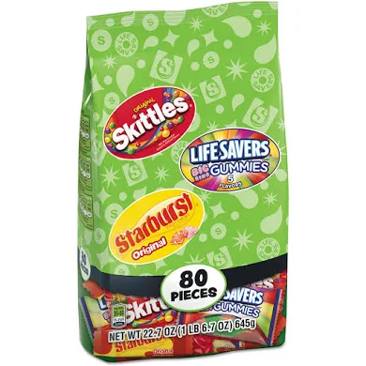
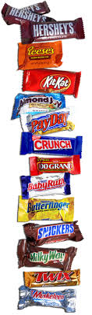
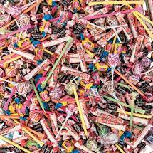
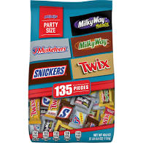

There will be a central repository for the donated candy and the Candy Stash Person will visit you throughout the night to refill your candy.

Prizes:
Prizes will be given at 8:25pm at the Pavilion for the Top 3 most creative vehicles.

What if it rains or snows?
If there is inclement weather on Wednesday, October 28, we will move the event to Friday, October 30 and all times remain the same. (If the event is changed to Friday due to weather, we will still have regular services on Wednesday for all groups.)

